**Assignment 1**

**Reading Part :**

**History of java:**

* Developed in 1991 By team of James Gosling, Patrick Naughton, Mike Sheridan. This team is also known as ‘Green team’.
* In 1992 they build one project named as “*7” which is set up box project but that got failed
* In 1994 Java team build browser named as “Web Runner” and “Applet”.
* In 1996 1st version of java is launched
* 2010 Oracal acquired java and SQL

**Java Language Features:**

* Java is a **Technology** as well as **Platform**
* Java is a:
  + - Object Oriented
    - Procedure Oriented
    - Function Oriented
* Java is a strictly Type check language.
* Most secure language

**Java Edition:**

* **Java SE (Standard Edition):** For Core java
  + **Components of Java SE:**
    - API
    - JVM
* **Java EE** **(Enterprise Edition):** For Advance java
  + **Components of Java EE:**
    - Servlet
    - Spring
    - Springboot
    - Java mail
* **Java ME** **(Micro Edition):** To Develop application for embedded system
* **Java FX** **(GUI):** Graphical User Interface
* **Java Card** **:**  For smart cards.

Assignment Task:

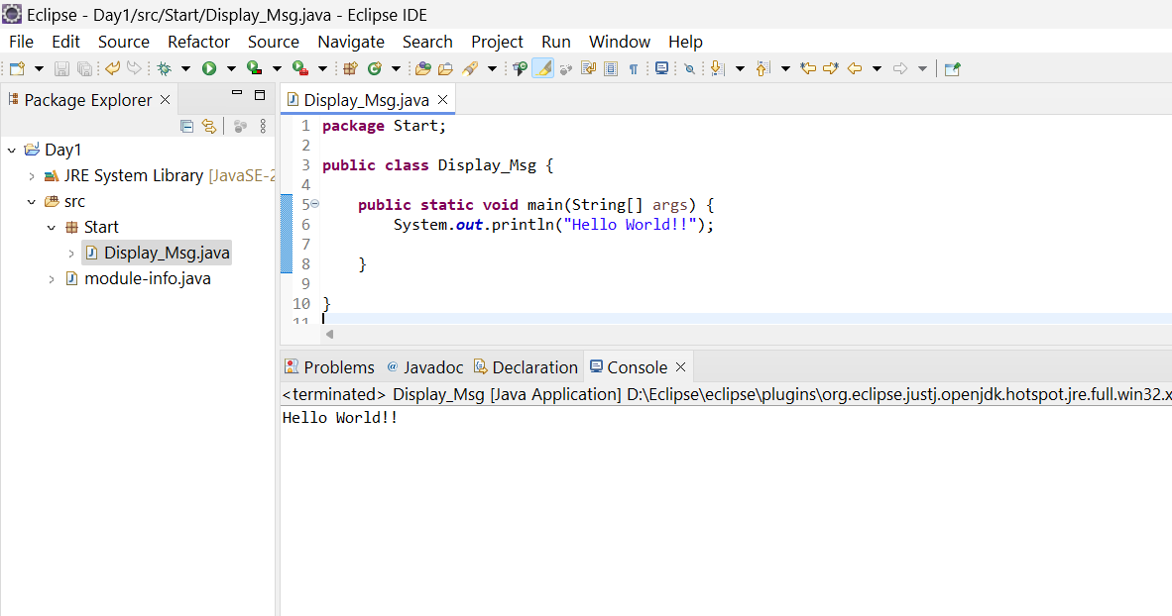

2. Compile with Verbose Option: Compile your Java file using the -verbose option with javac. Check the output.

3. Inspect Bytecode: Use the javap tool to examine the bytecode of the compiled .class file. Observe the output.

